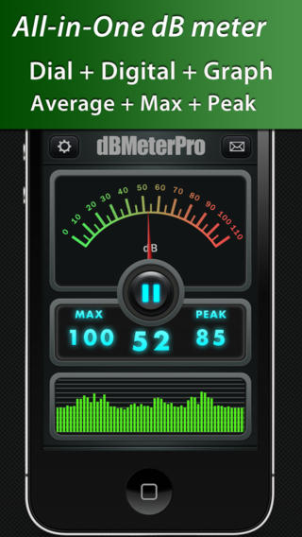
Sound Intensity

How it Works.
Clearly all smartphones have a microphone to enable talking. These apps take advantage of the microphone to measure ambient background sound levels. Because microphones are originally engineered to accommodate the normal ranges of speech, they are limited in the range of loudest and weakest sounds they can detect and measure spanning a range from about 60 dB to 120 dB.
Sound levels are measured in units of decibels (dB) which like the magnitude units used by astronomers to describe star brightness, is a logarithmic unit of sound power through a surface. dB = 10Log₁₀(P1/P0) where P0 is a reference power level of 1 picoWatt (10⁻¹² watts). An increase of 3 dB equals a power increase by a factor of 2.0, so an increase by 6 dB or 3+3 db equals 2x2 or 4. In terms of actual watts ,P1, a 60dB sound leads to a sound power of 10⁻⁶ watts and 120dB yields 1 watt.
Professional evaluations of these apps using variable intensity white-noise generators show that over their dynamic ranges they can be accurate to about +/- 2.0 dB using test sources of known amplitude. However, some professional evaluations also suggest that the use of smartphone apps in real-world situations is fraught with inaccuracy, and that well-trained ears would be better indicators than some of the software/hardware that was evaluated. Note, 3 db is also the smallest light intensity change the human eye can discern in terms of the brightness of stars in the sky! You can get compact, external microphones that clip into your headphone jack, but some evaluations suggest that they didn’t make a huge difference in the fidelity or sensitivity of the recordings.
App Descriptions
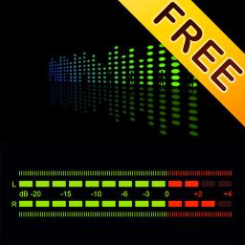
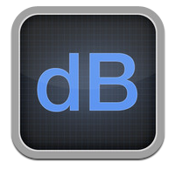
DecibelMeter (Android; iOS) – Simply launch the app and start reading the sound levels that surround you every day! Want to know just how loud this club is? Just how loud is this lecture anyhow? How good is the sound isolation in this room? Decibel Meter (Pro) can help you on these case! Download Decibel Meter (Pro) and measure the sounds around you right now! Decibel Meter (Pro) also tells you decibel exposure time guidelines. It tells you how loud is too loud. It tells you what's Noise induced hearing loss and how to avoid it. The iPhone's built in microphone is sensitive from 0 to approximately 110 decibels. Why aren't you getting a 0 decibel reading in a quiet room? A decibel is an actual measurement of sound pressure and aside from a vacuum chamber or out in space 0 dB is not really possible to read. An average quiet room will be in the 40-50 dB range. - Plotted history of the Average values. - Record and export the data to email for further analysis.(Pro Version)
Decibel Level (Android; iOS) included annoying popup advertisements. Gives peak, average and current readings at slow-enough rate to follow.

Decibel Sound Meter (Android; iOS). Very poor display. Numbers change too fast to really see ranges for a given measurement.
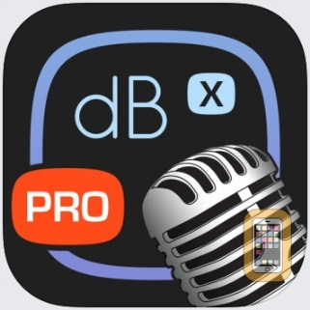
DeciBel 10th (Android; iOS) Decibel 10th" is one of very few noise/sound meter apps on the market having highly reliable and pre-calibrated measurements. Time weightings (Response Time): SLOW (500 milliseconds) and FAST (200 milliseconds)- Trimming calibration from -15dB to 15dB- Standard measurement range from 30 to 130 dB(A) Although all devices are pre-calibrated, custom calibration is suggested for serious purposes requiring higher precision and accuracy. You will need a real external device or calibrated sound meter as a reference, then adjust the trimming calibration until the reading matches with the reference. Provides nice linear plot in real time with export as CSV file. Gives average and max reading. My preferred meter…easy to use.

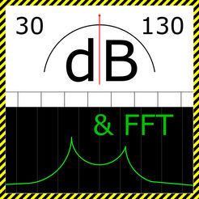
SPLnFFT Noise Meter ($3.99) Our highest rated iPad-based app is the SPLnFFT app. It received our highest possible rating –It costs only $3.99. During the four tests we conducted, this was the only app to absolutely nail the results each and every time. It passed all four tests with flying colors. In fact, this app’s results were so close to the results obtained using the $2,000 noise meter that the tiny differences between the two are probably due to sampling error. We do have one major concern about this app – it will only measure noise up to a maximum of 94 decibels! For review see: http://www.safetyawakenings.com/safety-app-of-the-week-42/

Relative Performance Tests
Smartphone was placed on flat surface face up with microphone exposed. None of these free apps allow for storing and sending data via a spreadsheet or text file.
Source | DecibelMeter +/-3 dB | Decibel Level  +/-4 dB | Decibel Sound Meter  +/-4dB | DeciBel-10th  +/-2 dB
According to Developer |  |  |  | 30 is minimum
Summit of Mt Greylock | 63 | 65 | 38 | 39
Basement | 58 | 62 | 35 | 45
Quiet Room | 58 | 59 | 30 | 43
Quiet Room | 63 | 62 | 55 | 47
Goddard office: door closed | 60 | 59 | 38 | 50
Greenbelt Park meadow | 70 | 60 | 59 | 57
Goddard outside | 72 | 76 | 45 | 58
Toyota Corolla inside | 68 | 75 | 48 | 56
Outside house with leaves | 70 | 75 | 35 | 59
Outside house no leaves | 76 | 73 | 50 | 60
Room with TV | 73 | 73 | 70 | 68
Toyota Corolla outside | 75 | 76 | 55 | 65
Freeway by Cedar Lane | 84 | 78 | 55 | 69
Queen Concert Audience | 80 | 80 | 65 | 75
Jet plane at cruising altitude | 92 | 88 | 70 | 86
Electric Lawn Mower | 89 | 86 | 70 | 86
Jack Hammer @ 10 meters | 89 | 67 | 73 | 86
Queen Rock Concert Music | 95 | 85 | 75 | 109
According to Developer |  |  |  | 130 is maximum

‘Freeway’ – was a measurement taken near the Cedar Lane overpass for 495 in Kensington, Maryland.
‘Lawn Mower’ – was taken 1 meter from an idling electric lawn mower.
‘Rock Concert’ – Was taken at the Queen Concert in Washington DC on July 31, 2017 – Audience is with no band playing, Music is during song ‘We will rock you’
‘Outside house no leaves’ taken in front of house with no leaves on trees in late-winter April 4
‘Mt Greylock Summit’ in the fog was absolutely quiet to my ears. Much more so than any other location sampled. Here is the trace of the data from Decibel 10th.
‘Toyota Corolla’, 2013 model….idling: outside hood up at bumper. Inside doors windows closed.
‘Greenbelt Park meadow’ – The sampling spot was 1 km from nearest house and roadway (Greenbelt Road and Rt 295). Noticably not as quiet as summit of Mt Greylock.

Noise level chart: http://www.noisehelp.com/noise-level-chart.html

Given that the dB scale is logarithmic, the variation in the measured values from app to app is significant. The app Decibel-10th seems to be the superior app in this test run. An absolute sound measurement has to be made with professional equipment to determine reliability for absolute measurements.

Finding the Zero-Level.
How do the apps respond when there is no sound energy applied? In other words, where is the Zero-level in dB of the sensor? To determine this, the app must be placed in a container in which no external sound energy penetrates. Ideally, an evacuated pressure chamber would be used, but these are expensive.
A closed box in a quiet environment might suffice, such as from the scale above a basement area with no discernable sounds from A/C, fan, heating or other units in operation. When I did this, the result was a reading with Decibel 10th that was 45 dB. Between my basement and Mt Greylock I have not seen a reading smaller than 35 dB. The box set-up does not seem to make a difference in isolating the sensor from the noise-generating environment. Without the bell-jar vacuum test I can only assume that for practical purposes, the 35 dB value is close to the minimum possible reading. There may be an internal electrical issue that creates in the audio circuit a baseline minimum sound level, or the micro-mechanical pressure sensor itself has a minimum energy threshold.
Note from Decibel 10 Apple Store: Please do not expect a quiet room reading will be 0 dB(A). The range 30-130 dB(A) is the standard usable range and an average quiet room will be about 30 dB(A).

