Exploring Proton Storms with the ***Parker*** ***Solar Probe***

SPEs have been observed at Earth for decades and carefully measured. The following table shows the seven events that occurred during 2011. The intensity is indicated by the number of particles per second that pass through a given square-centimeter of area at Earth orbit. Each event lasts about 2 hours. There were no events between 2007-2010

|  |  |  |  |
| --- | --- | --- | --- |
| Date | Intensity | Date | Intensity |
| March 8, 2011 | 50 | August 9, 2011 | 26 |
| March 21, 2011 | 14 | September 23, 2011 | 35 |
| June 7, 2011 | 72 | November 26, 2011 | 80 |
| August 4, 2011 | 96 |  |  |

**Problem 1** – The intensity of SPEs is known to approximately follow an inverse-square law. If Earth is 149 million kilometers from the sun, and the Parker Solar Probe spacecraft will be as close as 9.5 million kilometers, how much more intense will the tabulated SPEs be for the Parker Solar Probe?

**Problem 2** – If the Parker Solar Probe will spend about 8 months of its mission closest to the sun in its orbit, about how many events will it encounter more intense than 15,000 units?

**Problem 3** – SPEs are known to damage solar panels on satellites in orbit around Earth. If the Parker Solar Probe loses 2% of its power for events stronger than 15,000, how much power will the spacecraft lose in 7 years?

Solar Proton Events (SPEs) are intense bursts of high-energy protons created as dense clouds of plasma are ejected from the sun. The Parker Solar Probe will have a ring-side seat to observe how these events are caused. This will help scientists create better models to forecast when they will occur, and how damaging they will be to expensive satellites when they arrive at Earth.

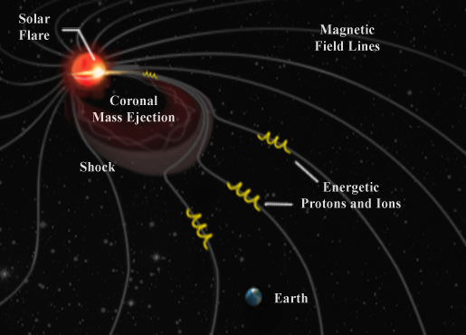

**Problem 1** – The intensity of SPEs is known to approximately follow an inverse-square law. If Earth is 149 million kilometers from the sun, and the Parker Solar Probe spacecraft will be as close as 9.5 million kilometers, how much more intense will the tabulated SPEs be for the Parker Solar Probe?

Answer: (149/9.5)**2** = 246 times greater, so the events will span a range from 14x246 = 3,444 pFUs to 96x246= 23,616 pFUs.

**Problem 2** – If the Parker Solar Probe will spend about 6 months of its mission closest to the sun in its orbit, about how many events will it encounter more intense than 15,000 units?

Answer : The table shows 3 events brighter than (58x256=15000) in 12 months, so you have about 1 event every 4 months, and so in 8 months you will get about 2 events.

**Problem 3** – SPEs are known to damage solar panels on satellites in orbit around Earth. If the Parker Solar Probe loses 2% of its power for events stronger than 15,000, how much power will the spacecraft lose in 7 years?

Answer: At about 1 event every 4 months you have 21 events in 7 years, so the loss is 42%.

Answer Key