Exploring Solar Heating with the ***Parker*** ***Solar Probe***

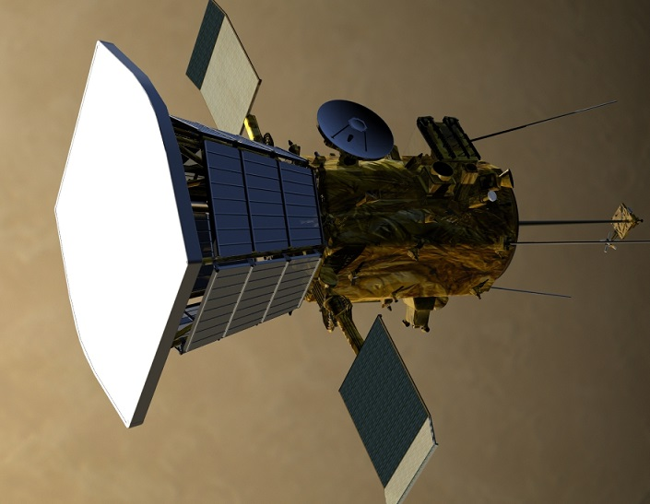

**Problem 1** – At the distance of Earth, F = 1378 watts/meter2. If the sun-facing heat shield on the spacecraft has a reflectivity of exactly 60%, how hot will the heat shield get in space?

**Problem 2** – The previous calculation assumed that the heat shield absorbed radiation from the sun, and only emitted its heat energy from the same face. In fact, both the front and shaded back side of the heat shield are emitting the heat energy, so the correct formula to use is

F = 2 x (5.67x10-8 (1-A)T4)

What is the more accurate answer for the heat shield temperature in Problem 1?

**Problem 3** – At its closest distance to the sun, the intensity of sunlight will be 250 times what it is near Earth. What will be the heat shield temperature at that point?

**Problem 4** – The spacecraft Thermal Control System uses a set of cooling vanes and ablation of material from the heat shield to dump most of the heat energy. If the heat shield has an area of 7.8 meter**2** and the final temperature at the back of the heat shield is 400 kelvins, how many watts of heat energy have to be eliminated by the TCS at perihelion?

Any surface in space near the sun will heat up as it absorbs solar energy. It will absorb sunlight at all wavelengths, but it can only cool off by emitting infrared radiation, which we experience as ‘heat’ radiation making the body warm to the touch. The mathematical relationship between the amount of energy it absorbs and the temperature it reaches is given by the Stefan-Boltzman Law:

F = 5.67x10**-8** (1-A) T**4**

Where F is the power per unit area (watts/meter2), T is its temperature in kelvin units, and A is the reflectivity of the surface.

**Problem 1** – At the distance of Earth, F = 1378 watts/meter**2**. If the sun-facing heat shield on the spacecraft has a reflectivity of exactly 60%, how hot will the heat shield get in space?

Answer: 1378 = 5.67x10-8 (1-0.60) T4

So T4 = 1378/(0.4 x 5.67x10-8) = 6.1x1010 and so **T = 500 kelvins**.

**Problem 2** – The previous calculation assumed that the heat shield absorbed radiation from the sun, and only emitted its heat energy from the same face. In fact, both the front and shaded back side of the heat shield are emitting the heat energy, so the correct formula to use is

F = 2 x (5.67x10-8 (1-A)T4)

What is the more accurate answer for the heat shield temperature in Problem 1?

Answer: 1378 = 2 x 5.67x10-8 (1-0.60) T4

So T4 = 3.1x1010 and so

**T = 420 kelvins**.

**Problem 3** – At its closest distance to the sun, the intensity of sunlight will be 250 times what it is near Earth. What will be the heat shield temperature at that point?

Answer: 1378x250 = 2 x 5.67x10**-8** (1-0.60)T**4**

T**4** = 7.6x10**12** so

**T = 1700 kelvins**.

**Problem 4** – The spacecraft Thermal Control System uses a set of cooling vanes and ablation of material from the heat shield to dump most of the heat energy. If the heat shield has an area of 7.8 meter**2** and the final temperature at the back of the heat shield is 400 kelvins, how many watts of heat energy have to be eliminated by the TCS at perihelion?

Answer: At perihelion, the solar energy is 250 x 1378 watts/meter**2** = 340000 watts/m**2**. The power received by the heat shield is then P = 340000 watts/m**2** x 7.8 meters**2** = 2,700,000 watts.

The back of the heat shield radiates 5.67x10**-8** (1-0.6)(400)**4** = 580 watts/meter**2**, so for 7.8 meters**2** area this is 4500 watts.

So the TCS has to eliminate 2,700,000 – 4500 = **2,700,000 watts of heat energy!**

Answer Key