Exploring Solar Energy with the ***Parker*** ***Solar Probe***

**Problem 1** – At Earth, located 149 million kilometers from the sun, sunlight delivers 1350 watts of energy to every square meter of surface area, tilted so that the area is exactly perpendicular to the direction of the sunlight. The Parker Solar Probe spacecraft uses two solar panels, each with an area of 1.5 meters2, that can convert 28% of this sunlight energy into electricity. How much electrical energy will the spacecraft generate in this way?

**Problem 2** – The intensity of sunlight increases with distance according to the inverse-square law. At half the distance, the intensity is four times as great. When the spacecraft reaches the orbit of Mercury located 50 million km from the sun, what will be the electrical power produced by the solar panels in Problem 1?

**Problem 3** – Suppose the same solar panel system was used when the spacecraft reached its closest distance to the sun of 9.5 million kilometers. How much more intense will the sunlight be at this distance compared to near Earth, and how much power will the panels produce?

**Problem 4** – During its journey to the orbit of Mercury, the solar panel system cannot generate more than 1200 watts without damaging the electrical system. How would you design the solar panels so that as the distance to the sun decreased, the panels never generated more than 1200 watts of energy?

NASA’s mission to the sun will be powered by two different solar panel systems. The first system, shown deployed in the figure, will operate when the spacecraft is between the orbit of Earth and Mercury. These panels will be retracted behind the heat shield to avoid damage. A second solar panel system will then take over and carefully poke out from behind the heat shield to generate just enough electricity to run the 480-watt spacecraft as the spacecraft travels to 9.5 million kilometers from the sun. Why do we need two systems?

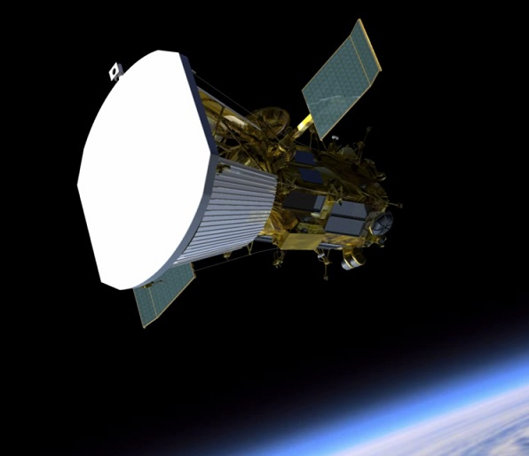

**Problem 1** – At Earth, located 149 million kilometers from the sun, sunlight delivers 1350 watts of energy to every square meter of surface area, tilted so that the area is exactly perpendicular to the direction of the sunlight. The Parker Solar Probe spacecraft uses two solar panels, each with an area of 1.5 meters2, that can convert 28% of this sunlight energy into electricity. How much electrical energy will the spacecraft generate in this way?

Answer: 1350 watts/m2 x 2 panels x 1.5 m2/panel x 0.28 = **1100 watts**.

**Problem 2** – The intensity of sunlight increases with distance according to the inverse-square law. At half the distance, the intensity is four times as great. When the spacecraft reaches the orbit of Mercury located 50 million km from the sun, what will be the electrical power produced by the solar panels in Problem 1?

Answer: The intensity of sunlight will be (149 million/50 million)2 = **8.9 times as great**, so the electrical power produced will be 8.9 x 1100 watts = **10,000 watts**.

**Problem 3** – Suppose the same solar panel system was used when the spacecraft reached its closest distance to the sun of 9.5 million kilometers. How much more intense will the sunlight be at this distance compared to near Earth, and how much power will the panels produce?

Answer: (149 million km/9.5 million km)2 = **250 times more intense**, and the solar panel power will be 250 x 1100 watts = **280,000 watts**.

**Problem 4** – During its journey to the orbit of Mercury, the solar panel system cannot generate more than 1200 watts without damaging the electrical system. How would you design the solar panels so that as the distance to the sun decreased, the panels never generated more than 1200 watts of energy?

Answer: From Problem 2 we have to reduce the area of the arrays by a factor of 10,000/1200 = 8.3 times. Because we can’t change the efficiency of the solar cells (28%), we have to adjust the area of the solar panels that the sun sees. We can do this by 1) using a shade that blocks out some of the surface of the panels, or 2) rotate the panels so that they are no longer perpendicular to the sun.

The first system could involve a window shade that rolls up across the panels changing their area from 1.5 m2 at Earth to 0.18 m2 near Mercury.

The second system would rotate the panel from 90 degrees at Earth to a smaller angle near Mercury. From basic geometry, I = 10000sin(theta) so to get I = 1200 watts, we need theta = 7 degrees. This is almost ‘edge on’ to the direction of the sunlight. The area of the array that the sun sees at this angle is only 1.5 meter2 x sin(7) = 0.18 m2.

Answer Key