Exploring Fractions with the ***Parker*** ***Solar Probe***!

**Problem 1** – If the Guidance System is 2/3 the mass of the Instrument System, and the Thermal Control System is 1/3 the mass of the Instrument System, what is the mass of the Guidance System in terms of the mass of the Thermal Control System?

.

**Problem 2** – The Avionics System is 1/10 the mass of the Power System. The spacecraft Structure System is 1/2 the mass of the Power System, and the Telemetry System is ¼ the mass of the Power System. What is the total mass of all four systems expressed in terms of the mass of the Power System?

**Problem 3 -** If the Telemetry System has a mass of 35 kilograms, what is the total mass of all four systems rounded to the nearest kilogram?

The Parker Solar Probe spacecraft consists of 11 separate systems, each with their own total mass in kilograms.

When engineers design a spacecraft, they have to follow strict mass limits so that the total mass of the spacecraft isn’t more than the rocket can carry into orbit.

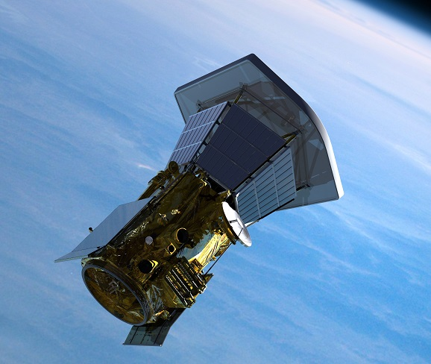

**Problem 1** – If the Guidance System is 2/3 the mass of the Instrument System, and the Thermal Control System is 1/3 the mass of the Instrument System, what is the mass of the Guidance System in terms of the mass of the Thermal Control System?

Answer: Write out the information in the text as their mathematical equivalents:

G = 2/3I and TC = 1/3 I so

I = 3TC and so

G = 2/3 (3TC)

= 2 TC.

The Guidance System is twice the mass of the Thermal Control System.

**Problem 2** – The Avionics System is 1/10 the mass of the Power System. The spacecraft Structure System is 1/2 the mass of the Power System, and the Telemetry System is ¼ the mass of the Power System. What is the total mass of all four systems expressed in terms of the mass of the Power System?

Answer: A = 1/10 P S = ½ P T = 1/4P so

Total mass = (1 + 1/10 + ½ + ¼)P

= (100/100 + 10/100 + 50/100 + 25/100) = 185/100 P = **37/50 P**

**Problem 3** - If the Telemetry System has a mass of 35 kilograms, what is the total mass of all four systems rounded to the nearest kilogram?

Answer: Telemetry = ¼ Power = **35 kg** so

Power = **140 kg**.

Avionics = 1/10 Power = **14 kg**

Structure = 1/2 Power = **70 kg**

Answer Key