**Problem 1** – If the thickness of the heat shield is 17 centimeters, what is the total volume of the heat shield in cubic centimeters?

**Problem 2** – The heat shield is made from a special carbon-composite material with a density of 0.054 grams/cm3 (54 kg/m3). If the density of water is 1 gm/cm3 (1000 kg/m3) will the heat shield sink or float in a swimming pool?

**Problem 3** – If one cubic centimeter of the heat shield has a mass of 0.054 grams, what is the total mass of the heat shield in kilograms?

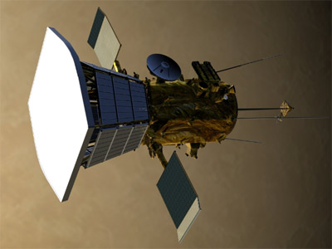

The NASA, Parker Solar Probe mission to be launched in 2017 will travel to a location very close to our sun. To prevent its delicate scientific instruments from over-heating, the entire spacecraft will ‘hide’ behind a heat shield like the one shown in the figure to the left. Also called the Thermal Protection System, it is roughly rectangular in shape with dimensions of 2.4 meters x 3.1 meters.

Exploring the ***Parker*** ***Solar Probe*** Heat Shield

**Answer Key**

**Problem 1** – If the thickness of the heat shield is 17 centimeters, what is the total volume of the heat shield in cubic centimeters rounded to two digits?

Answer: First convert all units to centimeters:

2.4 meters x (100 cm/1 meter) = 240 centimeters

3.1 meters x (100 cm/1 meter) = 3410 centimeters

Volume of a rectangular solid is V = L x W x H

= 240 x 310 x 17 = **1,300,000 cm3**.

**Problem 2** – The heat shield is made from a special carbon-composite material with a density of 0.054 grams/cm3 (54 kg/m3). If the density of water is 1 gm/cm3 (1000 kg/m3) will the heat shield sink or float in a swimming pool?

Answer: **The shield has less density than water so it will float.**

**Problem 3** – If one cubic centimeter of the heat shield has a mass of 0.054 grams, what is the total mass of the heat shield in kilograms?

Answer: 0.054 grams/1 cm**3** x 1,300,000 cm**3**

= 70,200 grams

70,200 grams x ( 1 kg/1000 gm) = **70.2 kilograms**